

EECE 460 – Project Report

Modeling and Control of a Ball-and-Beam System
Project report for course EECE 460 (Control Systems) at the Department of Electrical and ComputerEngineering, American University of Beirut, Lebanon
Fall 2024-2025
Report

Group Members:
- Haj Hassan, Fatima
- Sukkarieh, Jad

Dr. Naseem Daher
Date: 01/17/2025

Intro
One of the most fascinating control engineering problems to solve is balancing something fundamentally unstable, such as a ball and beam. This project aims to design and analyze a control system that stabilizes a ball in a tilting beam by changing the angle of the beam with an actuator. It’s a deceptively simple system, but it floats only with careful feedback and control. This project will along the way explore how to make the system more stable and responsive and also be a platform to test advanced control methods.
This system has an immediate connection to other classical engineering problems, such as the inverted pendulum, which itself requires active feedback to stay balanced. Most existing controllers, however, such as the Quanser Ball and Beam Apparatus, are PID controllers, which are decent at linear situations, but fail when disturbances or nonlinear dynamics need to be tackled. Our goal is to make a system so robust and versatile for the purpose of learning along with practical use. Additionally, in this report, we will discuss the dynamics of the ball and beam system, which include the equations of motion, the transfer function, and common techniques used to stabilize the system.
Literature review
Control engineers are confronted with a unique set of challenges when controlling unstable systems including inverted pendulums, stabilization platforms for robotics, and self-balancing robots and vehicles. However, such systems require accurate feedback structures to control their output around disturbances, nonlinear dynamics, and parameter variation. Beginning from fundamental classical to advanced control approach, researchers have handled these issues having their own merits and demerits.
The inverted pendulum system is a classic example of an unstable system that necessitates creative control strategies. A pendulum balancing vertically on a moving base is an unstable environment similar to stabilizing a ball on a beam. Hybrids of Proportional-Integral-Derivative (PID) and Linear Quadratic Regulator (LQR) controllers were analyzed by Nguyen and Vu (2016) and found to provide effective stabilization facing external disturbances. The hybrid method provided a compromise between fast responsiveness while maintaining great stability with little overshoot. However, in addition to being simple, both the ball-and-beam system and the inverted pendulum are also very sensitive to changes and disturbances to the parameters, so robust and adaptive control designs need to be used.
Other systems like robotic arms and self-balancing robots also introduce similar problems and hence cause the use of higher-order control approaches. Most robotic arm stabilization systems utilize state-space methods such as LQR noted by Wang and Zhang (2012) whereby the performance is adjusted until the cost function is minimized and remains quadratic. In this, self-balancing robots use feedback and feed-forward control schemes to counterbalance in shifty situations. While sharing the need for accurate feedback and immediate response with the ball-and-beam, these systems typically reside in the more challenging operating environment and challenge the design of the controller.
Classical PID controllers have been long in use as one of the basic options for dealing with the unstable processes because of their simplicity and implementation. This is supported by findings in the works of Lee et al. (2010) and Yilmaz (2015) where PID was shown to be capable of delivering steady performance in balancing systems when disturbances and nonlinearities are minimal. Nevertheless, in systems where systems have nonlinearity such as the ball-and-beam or inverted pendulums, the use of standalone PID controllers is likely to offer sub-optimal performance. To overcome these drawbacks, researchers have integrated PID with other approaches like state space control since it is considered to offer enhanced stability and flexibility among other benefits.
In connection with the challenges of unexpectedly developed nonlinear and dynamic systems, modern studies appeal to the methods of Sliding Mode Control (SMC) and intelligent approaches. In support of using the specified model for platforms such as inverted pendulums and robotic systems, Ghosh et al. (2017) employed simulations to establish SMC’s efficacy regarding reaction to uncertainties and disturbances. However, the effects of chattering which are associated with the SMC can only be mechanical, thus putting a constraint on its usefulness. Fuzzy logic neural networks, and other intelligent controllers are capable of offering the right response to different conditions within the system. Sharma and Kumar (2018) pointed out that fuzzy logic controllers outperform the PID in the context of overshoot and settling time that presents important information on improving the design of controllers for unstable systems.
setup
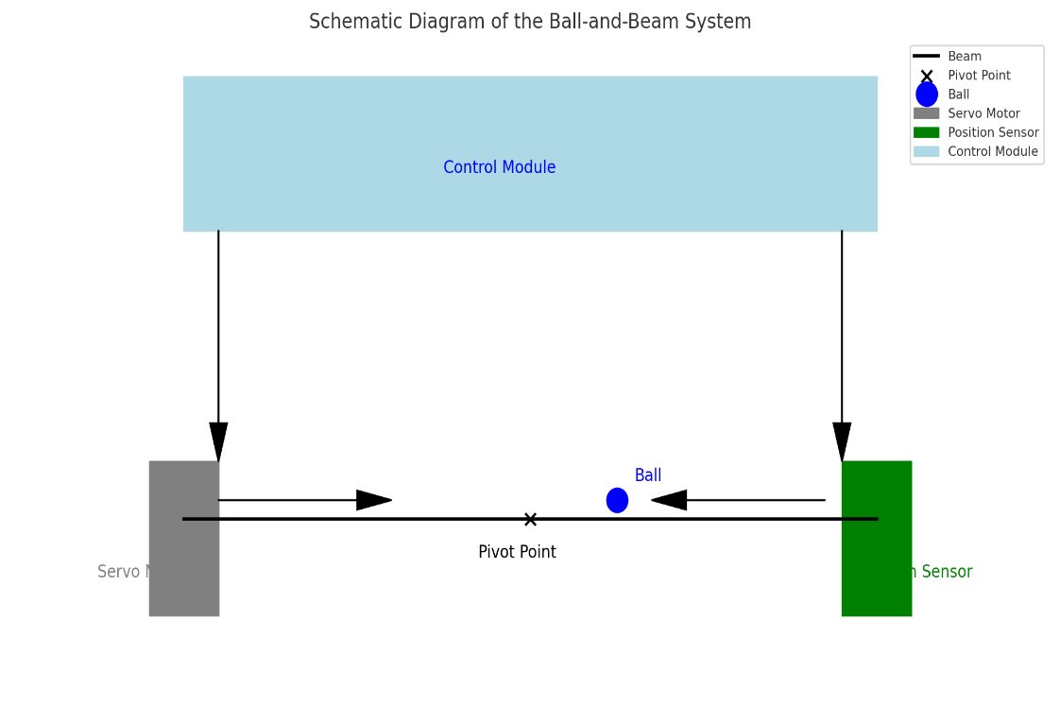
Figure 1
Ball and beam is one of the classical experiments in control engineering for teaching the concepts of stability and feedback. A simple setup with a beam balanced at a pivot and a ball that is allowed to roll back and forth on it. The beam is tilted by a servo motor, the position of the ball is tracked by a sensor, and the control module takes decisions to keep the ball steady. The action has to control the angle of the beam so that a target range will be maintained.
How It Works
Every part of the system has a job to do. The beam gives the ball a surface to roll on moving up or down as the motor acts. The ball, which moves because of gravity is what the system focuses on – keeping it balanced is the main task. The servo motor's job is to tilt the beam to affect how the ball moves. The position sensor keeps track of where the ball is all the time sending updates right away to the control module, which works as the system's brain. This module takes in the sensor's information, looks at it next to where we want the ball to be, and tells the motor how much to change the beam's angle.
Joining things together
The beauty of this setup is in how all the parts work as one. As the ball moves, the sensor picks up the change and relays this info to the control module. This module figures out how far off the ball is from its ideal spot and tells the motor to tilt the beam just enough to fix it. This back-and-forth happens non-stop keeping the ball steady even if something knocks it or the beam shifts a bit.
You can also tweak this setup. For instance, you can adjust the motor to make faster or more exact moves, and you can improve the control algorithms to react quicker or more, based on what you need. The sensor is a crucial part as it makes sure the system always has the correct data to use, making it vital for keeping things stable.
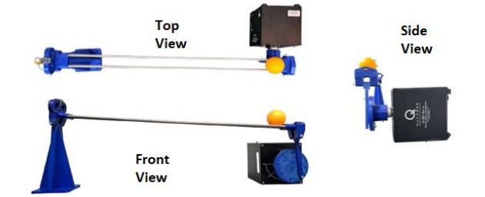
Figure 2

Modelling
For ball and beam (P_{bb})
Using The Lagrangian method:
$$L=K-P$$
K: translational + rotational
Translation: $\frac{1}{2}m_{b}{{\dot{X}}_{b}}^{2}$
Rotational: $\frac{1}{2}Jw^{2}=\frac{1}{2}J{(\frac{{\dot{X}}_{b}}{R})}^{2}$
K= $\frac{1}{2}{{\dot{X}}_{b}}^{2}(m_{b}+\frac{J}{R^{2}})$
$P= mgX_{b} sin⁡(∝)$ $\sin\left(∝\right)= ∝$ for small $∝$
L= $\frac{1}{2}{{\dot{X}}_{b}}^{2}\left(m_{b}+\frac{J}{R^{2}}\right)-mgXb(∝)$d
$$\frac{d}{dt}\left(\frac{dL}{d{\dot{X}}_{b}}\right)-\frac{dL}{dX_{b}}= -BX_{b}$$
B=damping constant
$$\frac{d}{dt}\left[{\dot{X}}_{b}\left(m_{b}+\frac{J}{R^{2}}\right)-0\right]-\left[0-mg∝\right]$$
$$∝=\frac{d}{L}θ$$
$$\left[m_{b}+\frac{J}{R^{2}}\right]{\ddot{X}}_{b}+\frac{mgd}{L}θ= -B{\dot{X}}_{b}$$
Laplace transform:
$$\left[m_{b}+\frac{J}{R^{2}}\right]s2 X\left(s\right)+\frac{mgd}{L}θ\left(s\right)= -BsX(s)$$
$$X\left(s\right)\left[s2\left(m_{b}+\frac{J}{R^{2}}\right)+Bs\right]= -\frac{mgd}{L}θ(s)$$
$$P_{bb}(s)=\frac{X\left(s\right)}{θ\left(s\right)}= -\frac{mgd}{L\left[s2\left(m_{b}+\frac{J}{R^{2}}\right)+Bs\right]}$$

For the Motor:
$$J\ddot{θ}+b\dot{θ}=K_{m}i$$
$$L_{m }\frac{di}{dt}+R_{m}i=V_{m}-K\dot{θ}$$
Laplace:
$$Js^{2}θ\left(s\right)+sbθ\left(s\right)=K_{m}I(s)$$
$$L_{m}sI\left(s\right)+R_{m }I\left(s\right)=V_{m}\left(s\right)-Ksθ(s)$$
$${(L}_{m}s+R_{m})I\left(s\right)+Ksθ\left(s\right)=V_{m}(s)$$
$$[{(L}_{m}s+R_{m})\frac{(Js^{2}θ\left(s\right)+sbθ\left(s\right))}{K_{m}}]+Kθ(s)={ V}_{m}(s)$$
$$P_{m}(s)=\frac{θ\left(s\right)}{V_{m}\left(s\right)}=\frac{K_{m }}{[\left(s^{3}\left(JL_{m}\right)+s^{2}\left(R_{m }J+L_{m }b\right)+s\left(R_{m}b+K_{m}K\right)\right]}$$
Neglect L_{m}

$$P_{m}(s)=\frac{θ\left(s\right)}{V_{m}\left(s\right)}=\frac{K_{m }}{[\left(s^{2}\left(R_{m }J\right)+s\left(R_{m}b+K_{m}K\right)\right]}$$
Divide by R_{m} and since K_{m} = K
$$P_{m }(s)=\frac{θ\left(s\right)}{V_{m}\left(s\right)}=\frac{K_{m }/R_{m} }{[\left({Js}^{2}+s\left(b+\frac{{K_{m}}^{2}}{R_{m}}\right) \right]}$$
$$P\left(s\right)=P_{m}(s)+P_{bb}(s)$$
$$P\left(s\right)=\frac{\frac{mgd}{L}x\frac{K_{m}}{R_{m}}}{s^{4}\left[J\left(m_{b}+\frac{J}{R^{2}}\right)\right]+s^{3}\left[JB+\left(b+\frac{{K_{m}}^{2}}{{R }_{m}}\right)\left(m_{b}+\frac{J}{R^{2}}\right)\right]+s^{2}\left[B\left(b+\frac{{K_{m}}^{2}}{{R }_{m}}\right)\right]}$$

